# Foundations for a triumphal arch, but which victory might it commemorate?

This week Kiri H. discusses the attempts by scholars to interpret the meaning of the foundations of an arch excavated in the Forum Romanum. Much remains uncertain and debate is likely to continue!

In 1888, German archaeologist Otto Richter discovered the foundations of a three-bayed triumphal arch in the Roman Forum. Located between the temples of Caesar and of Castor, these foundations consisted of four rectangular concrete beds topped with travertine blocks, with the outer two bases being considerably narrower than the inner two. It was later recorded by Italian archaeologist Rodolfo Lanciani that the arch corresponding to these foundations had been “found and destroyed” by workmen in the 16th century (Lanciani, 1897: 269).

Richter had initially identified the foundations as belonging to an arch that was reportedly built in honour of Augustus after his victory at the Battle of Actium. Cassius Dio wrote of there being two arches dedicated to Augustus in the Forum; one in 29 B.C. for his victory at Actium, and one in 19 B.C. for recovering Roman standards and captives from the Parthians (Cass. Dio [51.19.1](http://penelope.uchicago.edu/thayer/e/roman/texts/cassius_dio/51*.html), [54.8](http://penelope.uchicago.edu/thayer/e/roman/texts/cassius_dio/54*.html)). Commentary on Vergil’s *Aeneid* by the Veronese Scholiast states that the ‘Parthian arch’ was located beside the Temple of Caesar @Holland. After fruitless excavations in search for the second arch, Richter decided the foundations, he had excavated between the temples of Caesar and of Castor were those of the Parthian arch of 19 B.C..

In the 16th century, an inscription (*CIL* VI, 873) on a marble block was discovered nearby to where Richter would later unearth the foundations. The (now lost) inscription recorded a dedication to Augustus in 29 B.C.**Find the inscription**; Platner suggested that it may have belonged to the triple-arch but noted that its size of 2.67 metres long would have been too small to be the principle inscription (Platner, 1929: 34). Also excavated in the 16th century were the *Fasti Consulares* and *Fasti Triumphatores* (image 6), fragments listing all those who had been consul, and those who who had received a triumph, respectively @Rose. Debate exists as to where the *Fasti* were originally located; the Regia, a building behind the Temple of Caesar, is one contender, with another being the Arcus Augusti.

Several Roman coins are believed to depict either one or both of the arches @Holland. The earliest coins are *denarii* from 29-27 B.C. which depict a *quadriga* atop a single arch, accompanied by the legend ‘IMP CAESAR’ (image 2).

*Denarii* minted in Spain, dating from 18-17 B.C., also depict a triple-arch. The outer piers are, too, considerably narrower than the inner piers, and support a *quadriga* flanked by figures holding Roman standards (image 3). The coins bear the legend ‘CIVIB ET SIGN MILIT A PART RECVP’, whilst on the reverse the head of Augustus and ‘SPQR IMP CAESARI AVG COS XI TRI POT VI’ can be seen ([ANS 1957.172.1501](http://www.romanatic.com/image-109)). Leicester Holland, an American architect, art historian and archaeologist, argued that these legends confirm that the arch depicted on the coins commemorates the recovery of the standards from the Parthians by Augustus @Holland.

Further, *denarii* minted in 16 B.C. by L. Vinicius in Rome also bear striking similarities. They depict the triple arch with narrow outer piers upon which stand the *quadriga* and its flanking figures holding Roman standards, with the inscription ‘S P Q R IMP CAE’ (image 4). Holland argued that the coins minted in Spain and Rome undoubtedly represent the same arch as, not only do they all bear the same crowning figures, but this is the only known triple arch present during this period @Holland.

Holland further argued that the coins minted by Vinicius present a more accurate image of the triple-arch than the Spanish *denarii*, because Vinicius “would be thoroughly familiar with a monument erected in his home city three years before” @Holland. On these grounds, Holland proposed that, in 29 B.C., a single arch was erected and, in 19 B.C., the two wings and statues were added, resulting in the triple-arch depicted by Vinicius @Holland.

However, excavations in 1950-52, led by Gamberini Mongenet, resulted in the discovery of two foundation piers spaced nearly 7m apart, located immediately in front of the northern end of the triple-arch foundations. These piers indicated the existence of an earlier, single-bayed arch at this location. Mongenet’s excavations also revealed that one of the piers was supported by “a complex system of bracing walls and underground props built to prevent a crack from developing” @Gurval. These finds concluded that the single-bayed arch was indeed the Actian arch, and that it was later demolished and replaced with the more ornate triple-bayed Parthian arch. In 1981, Italian archaeologist Filippo Coarelli proposed that the removal and the replacement of the Actian arch with the Parthian was a political manoeuvre, due to the fact that the former celebrated Augustus’s victory during the civil war, something from which, perhaps, Augustus later chose to distance himself (Simpson, 1992: 836).

In 1983-85, during excavations at the Temple of Castor and Pollux, the archaeological evidence was again re-examined. Some had proposed that the foundations were of the Parthian arch, built on top of the former arch of 29 B.C. This hypothesis was disproved by Elisabeth Nedergaard during her investigation, which dated the structure to between 29 B.C. and A.D. 6, thus concluding that it could not have been built over an older structure @RathjeLund.

Professor Paul Zanker, in 1990, argued that an arch was built next to the Temple of Caesar in honour of the “triple triumph of Augustus”, and bore the *fasti*. They, the *fasti*, were inscribed on marble slabs and attached to the arch, and state that the Senate decreed a triumph for Augustus, yet he refused. Despite this, the senate still erected a three-bayed arch featuring a quadriga “over Augustus’s objections” in order to recognise his achievements.

In 1992, C. J. Simpson reviewed the evidence surrounding the Parthian arch in order to clarify its speculative nature. Simpson argued that there is “no sure numismatic or historical evidence that the so-called Parthian arch was ever built” and that “we may legitimately suspect that the arch was never built” (Simpson, 1992: 841). This hypothesis was based on several key factors. Firstly, Simpson stated that the arch was decreed by the Senate in 19 B.C., but was not necessarily erected (Simpson, 1992: 836). Secondly, that there is no actual evidence of the identity of the respective foundations discovered by Richter and Mongenet, as those proposed were purely speculative. Additionally, Simpson questioned Coarelli’s proposal that the reasons behind the demolishment of the Actian arch had a political agenda, that of an attempt by Augustus to distance himself from the civil war, stating that he, Coarelli, was “just too imaginative” (Simpson, 1992: 836). Simpson found it “a very difficult concept to accept”, that the Actian arch could have been built, yet destroyed only a decade later (Simpson, 1992: 836).

The coins that are believed to be associated with the arch depict Augustus in a triumphal chariot. Yet Simpson cites Cassius Dio to provide evidence that Augustus refused to mount the chariot when returning to Rome in 19 B.C. ([Cass. Dio 54.8](http://penelope.uchicago.edu/thayer/e/roman/texts/cassius_dio/54*.html)), stating that it is unlikely a statue of Augustus in a triumphal chariot would have been erected when he “would not mount one in real life” (Simpson, 1992: 837). Simpson thus concluded that the coins are not evidence for the completion of an arch, but a portrayal of a projected monument. In 19 B.C., an altar to Fortuna (*ara Fortunae Reducis*) was erected in honour of Augustus, mentioned by him in his [*Res Gestae Divi Augusti* 11](http://classics.mit.edu/Augustus/deeds.html), and also by Cassius Dio ([Dio 54.10.3](http://penelope.uchicago.edu/Thayer/e/roman/texts/cassius_dio/54*.html)). However, Simpson goes on to explain that: it is only in the writings of Cassius Dio that a further arch and ovation were also used to honour Augustus. The *Res Gestae* mentions neither of these. Simpson highlights the inconsistencies of Dio as, despite his previous assertion, he later states that Augustus refused all honours but the altar; once again finding no clear evidence of the existence of the arch.

However, in 1998, Galinsky argued that both an Actium arch and a Parthian arch existed in the Forum, the latter next to Caesar’s temple @Galinsky. He stated that Augustus was involved “to varying degrees” in these building programs and that the triple arch was commissioned by the Senate @Galinsky.

In the same year, associate professor Robert Gurval reviewed the arguments surrounding the is with the foundations of the single arch and hence suggested that the removal of the arch may have been the result of a failed attempt to save a damaged monument @Gurval. However, Gurval goes on to argue that “the numismatic, literary, and archaeological evidence is inconclusive and uncertain”, and that historians need to move away from the notion that Augustus’s victory at Actium must have resulted in a commemorative arch @Gurval. Gurval stated that, despite Dio’s recording of an arch awarded to Augustus after the Battle of Naulochus in 36 B.C., there is no other evidence for the existence of the Actium arch nor that of Naulochus. Gurval suggested that it is inconsistent for scholars to believe one arch did exist and not the other @Gurval, thus proposing that a single arch did exist, but that it did not mention Actium and, instead, may have celebrated the overall general achievements of Augustus. He argued that the triple-arch did not replace the previous arch as a notion of political change, but that it “marked the beginning of the imperial age” @Gurval.

In 2005, American archaeologist Charles Rose agreed with Gurval in that it was uncertain as to whether the arches of Actian or Naulochus existed. Nonetheless, he argued that the triple-arch foundations in the Forum are, indeed, of the Parthian arch. Rose demonstrated that this was supported by “a wealth of evidence”, citing associated archaeological, numismatic and literary data in proof @Rose. He further analysed the form and fragments of the *fasti*, noting that the decorative elements associated with the consular and triumphal lists were more in keeping with the style of the Parthian arch than that of the *Regia* @Rose. Also, he highlighted that many of the *fasti* fragments were found surrounding the arch as opposed to the *Regia*, thus concluding that “all of the evidence points toward the Parthian Arch as the original site of the Fasti” @Rose. Additionally, the last *triumphator* listed on the Fasti Triumphales was awarded a triumph in the year the Parthian arch was decreed. Rose hence suggested that the Fasti were part of the Parthian arch, and probably located on the walls within the passages @Rose.

The discovery of the foundations of a triple-bayed arch in the Roman Forum in 1888 by Otto Richter sparked much intrigue and debate surrounding the nature of the Arcus Augusti, which continues to be a source of discussion, today. Scholars have examined and re-examined the available archaeological, numismatic and literary evidence in an attempt to understand if and how Augustus’s triumphal arches existed. This ongoing debate exemplifies how our understanding of the development of the city of Rome evolves as new evidence is continually brought to light. Yet it also encapsulates that a sizeable portion of our knowledge concerning ancient Rome is still based largely upon interpretation and speculation. As new technologies and techniques of research become available, we may use them in conjunction with the critical analysis of both modern and ancient sources to test hypotheses and examine past research. It is through this multi-faceted approach that we strive to create a more wholistic understanding of the nature of ancient Rome.

**Figures**

Figure 1: The location of the Arcus Augusti between the Temples of Caesar and Castor.

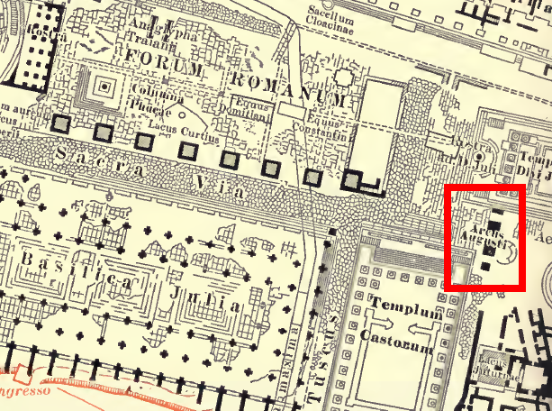

Figure 2: The foundations discovered by Richter highlighted in red, with the Temple of Divus Iulius (Caesar) and Temple of Vesta.

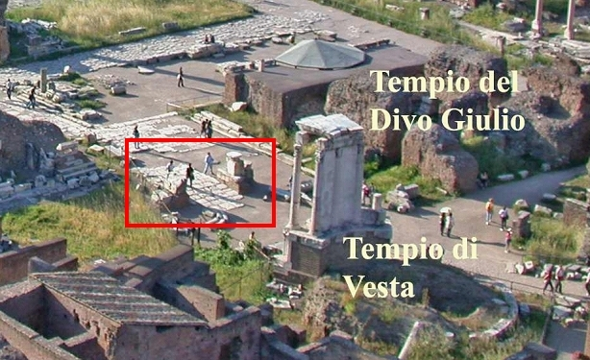

Figure 3: Denarius dated between 29 and 27 B.C.

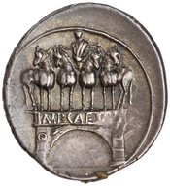

Figure 4: Denarius dated between 18 and 17 B.C.

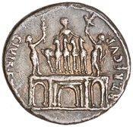

Figure 5: Denarius dated to 16 B.C.

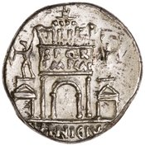

Figure 6: Fragments of the Fasti Consulares, now located in the Musei Capitolini in Rome.

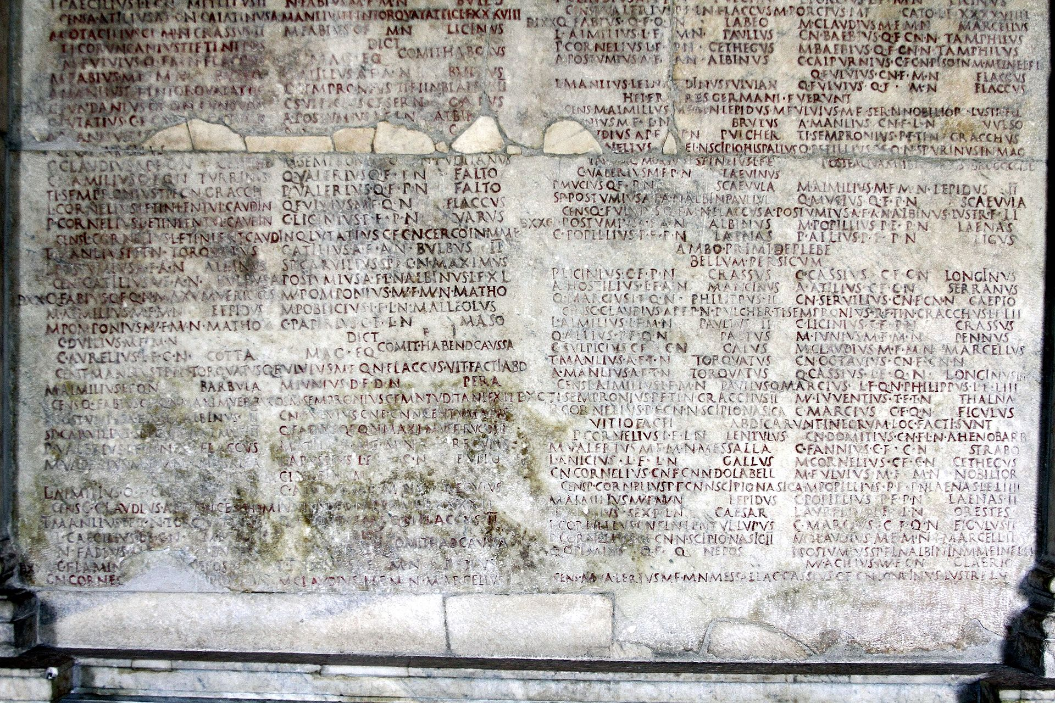

**Bibliography**

**Ancient Sources**

Cassius Dio, *Historia Romana*, trans. E. Cary (Cambridge: Harvard University Press, 1917),

*Lacus Curtius*, <<http://penelope.uchicago.edu/Thayer/E/Roman/Texts/Cassius_Dio/home.html>> (viewed 18th May, 2018).

Augustus, *Res Gestae Divi Augusti*, trans. T. Bushnell, *The Internet Classics Archive*,

<<http://classics.mit.edu/Augustus/deeds.html>> (viewed 18th May, 2018).

**Modern Sources**

Galinsky, K. (1998), *Augustan Culture: An Interpretive Introduction*, Princeton.

Gurval, R. A. (1998), “The Evidence for the “Actian” Arch”, *Actium and Augustus: The Politics and Emotions of Civil War*, Michigan, pp. 39-47.

Holland, L. B. (1946), “The Triple Arch of Augustus”, *American Journal of Archaeology 50:1*, pp. 52-59.

Lanciani, R. (1897), *The Ruins and Excavations of Ancient Rome*, Cambridge.

Platner, S. B. (1929), *A Topographical Dictionary of Ancient Rome*, London.

Rathje, A. & Lund, J. (1991), “Danes Overseas - A Short History of Danish Classical Archaeological Fieldwork”, in T. Fischer-Hansen (ed.), *Recent Danish Research in Classical Archaeology: Tradition and Renewal*, Copenhagen, pp. 11-57.

Rose, C. B. (2005), “The Parthians in Augustan Rome”, *American Journal of Archaeology* *109: 1*, pp. 21-75.

Simpson, C. J. (1992), “On the Unreality of the Parthian Arch”, *Latomus* *51: 4*, pp. 835-842.

Zanker, P. (1990), *The Power of Images in the Age of Augustus*, Michigan.

**Bibtex of Modern Sources:**

@book{galinsky1998augustan,

title={Augustan Culture: An Interpretive Introduction},

author={Galinsky, K.},

isbn={9780691058900},

lccn={lc95033469},

series={Princeton Paperbacks},

url={https://books.google.com.au/books?id=Ejwhh6cXwoQC},

year={1998},

publisher={Princeton University Press}

}

@book{gurval1998actium,

title={Actium and Augustus: The Politics and Emotions of Civil War},

author={Gurval, R.A.},

isbn={9780472084890},

lccn={95001844},

url={https://books.google.com.au/books?id=qVd4vuhkVqcC},

year={1998},

publisher={University of Michigan Press}

}

@article{10.2307/499748,

ISSN = {00029114, 1939828X},

URL = {http://www.jstor.org/stable/499748},

author = {Leicester B. Holland},

journal = {American Journal of Archaeology},

number = {1},

pages = {52--59},

publisher = {Archaeological Institute of America},

title = {The Triple Arch of Augustus},

volume = {50},

year = {1946}

}

@book{Lanciani,

title={The Ruins and Excavations of Ancient Rome},

author={R. Lanciani},

isbn={9781375746885},

year={1897},

publisher={Boston and New York, Houghton, Mifflin and Company}

}

@book{PlatnerAshby,

title={A Topographical Dictionary of Ancient Rome},

author={S. B. Planer & T. Ashby},

isbn={9788870626018},

url={http://penelope.uchicago.edu/Thayer/E/Gazetteer/Places/Europe/Italy/Lazio/Roma/Rome/_Texts/PLATOP*/home.html},

year={1929},

publisher={Oxford University Press}

}

@article{3a053bd074d111dbbee902004c4f4f50,

title = "Danes Overseas - A Short History of Danish Classical Archaeological Fieldwork",

abstract = "Ark{\ae}ologi, klassisk, historie, Middelhavet",

author = "Annette Rathje and John Lund",

year = "1991",

language = "English",

pages = "11--56",

journal = "Acta Hyperborea",

issn = "0904-2067",

publisher = "Museum Tusculanum",

number = "3",

}

@article{article,

author = {Brian Rose, Charles},

year = {2005},

month = {01},

pages = {21-75},

title = {The Parthians in Augustan Rome},

volume = {109},

booktitle = {American Journal of Archaeology}

}

@article{10.2307/41536451,

ISSN = {00238856, 22944427},

URL = {http://www.jstor.org/stable/41536451},

author = {C. J. Simpson},

journal = {Latomus},

number = {4},

pages = {835--842},

publisher = {Societe d’Etudes Latines de Bruxelles},

title = {On the Unreality of the Parthian Arch},

volume = {51},

year = {1992}

}

@book{zanker1990power,

title={The Power of Images in the Age of Augustus},

author={Zanker, P. and Shapiro, A.},

isbn={9780472081240},

lccn={88017279},

series={Jerome lectures},

url={https://books.google.com.au/books?id=pDc2fp73B2oC},

year={1990},

publisher={University of Michigan Press}

}

**Images**  
**Figure 1:**

*File:Arch of Augustus.png*  
Wikimedia Commons, (2018), accessed on 27 May 2018, <<https://commons.wikimedia.org/w/index.php?title=File:Arch_of_Augustus.png&oldid=299542765>>.   
License: Public Domain.

**Figure 2:**

*File:Arch of Augustus present.jpg.*   
Wikimedia Commons, (2014), accessed on 27 May 2018, <<https://commons.wikimedia.org/w/index.php?title=File:Arch_of_Augustus_present.jpg&oldid=124703662>>.   
License: CC BY-SA 3.0.

**Figure: 3**

*Silver Denarius of Augustus, Uncertain value, 29 BC - 27 BC. 1937.158.442 (unknown),* OCRE, American Numismatic Society, accessed on May 27 2018, <<http://numismatics.org/ocre/id/ric.1(2).aug.267>>.

**Figure 4:**

*Silver Denarius of Augustus, Colonia Patricia, 18 BC - 17 BC. 1957.172.1488 (unknown),* OCRE, American Numismatic Society, accessed on May 27 2018, <<http://numismatics.org/ocre/id/ric.1(2).aug.136>>.

**Figure 5:**

*Silver Denarius of Augustus, Rome, 16 BC. 1944.100.38331 (unknown),* OCRE, American Numismatic Society, accessed on May 27 2018, <<http://numismatics.org/ocre/id/ric.1(2).aug.359>>.

**Figure 6:**

*File:Fasti Consularii (detail) - Sala della Lupa - Palazzo dei Conservatori - Musei Capitolini - Rome 2016 (3).jpg (2016, September 24), © José Luiz Bernardes Ribeiro / CC BY-SA 4.0,* Wikimedia Commons, (2016), accessed on 27 May 2018, <<https://commons.wikimedia.org/wiki/File:Fasti_Consularii_(detail)_-_Sala_della_Lupa_-_Palazzo_dei_Conservatori_-_Musei_Capitolini_-_Rome_2016_(3).jpg>>.

License: CC BY-SA 4.0.  
© José Luiz Bernardes Ribeiro /, CC BY-SA 4.0., Wikimedia Commons